[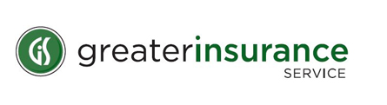](http://www.gismn.com/home.html)

I give Greater Insurance Service of Northeastern Minnesota Inc. permission to run a Motor Vehicle Report (MVR) on me since I drive the business vehicle for………

Company Name:

Printed Name: Date:

Drivers License Number:

Signature: Date: